**PRINT FORMAT ISSUES – 27.12.19**

**------------------------------------------------------------------------------------------------------------------------**

**General: *The Logo in the header is not so clear, do you need Logo in other size? In Lexware it is much sharper----> Completed***

* TOOL:

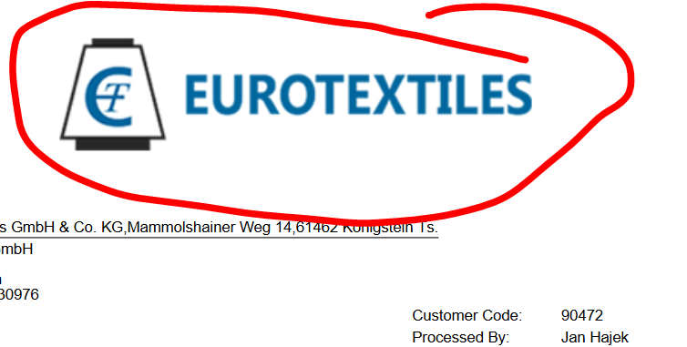

* LEXWARE:

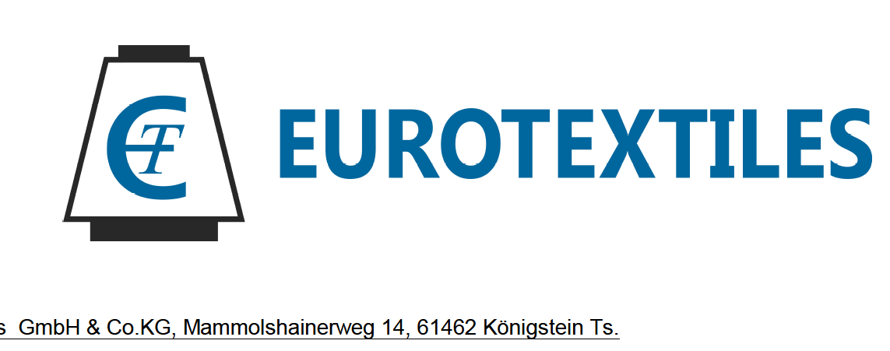

--------------------------------------------------------------------------------------------------------------------------------------

**English & German** Below Net Value the amount of the 19% VAT is schown, not the amount Inclusive VAT. Please just write in Englisch: **„19% VAT“** in German: **„19% USt.“*----> Completed***

**I believe his will be applicable for all Store/Trading printouts where tax is applicable**

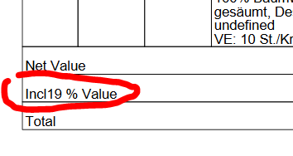

**STORES**

**Quotation**

***German: „Quotation No.“ Is „Angebot Nr.“ in German. „Zitat“ is not the right transplation.***

***----> Completed***

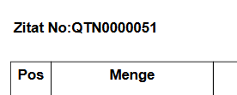

***German & English: Last two sentences not needed for quotation.***

***----> Completed***

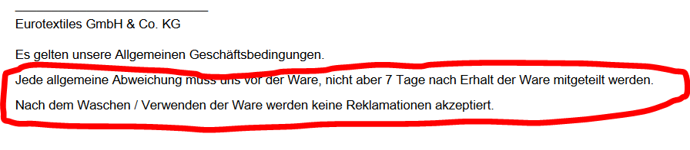

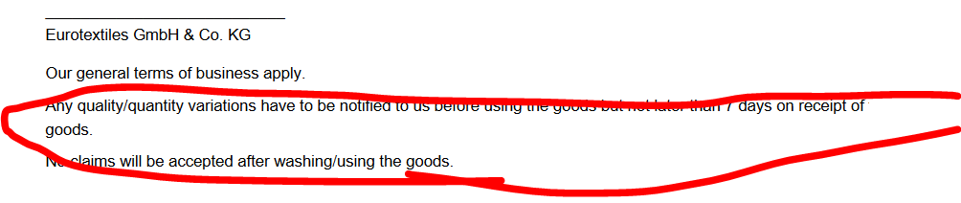

**ORDER**

**English & German:** VAT-ID (German: USt.-Id) not shown

***----> Completed***

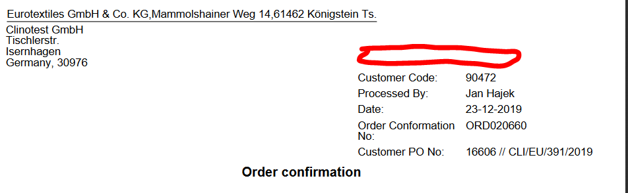

--------------------------------------------------------------------------------------------------------------------------------------

**German:** The „Confirmation No.“ Is translated wrong. „No“ means „Nein“ in German but it is the short form for „Number“ here which means „Nummer“ or „Nr.“ in german

***----> Completed***

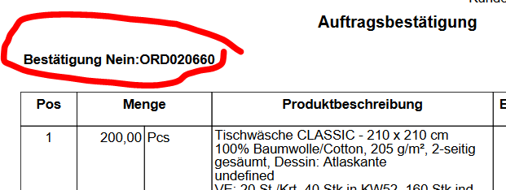

--------------------------------------------------------------------------------------------------------------------------------------

**German**: Between Line for signature and Company details big gap is there. Please remove this gap. In english version it is okay.

***----> Completed***

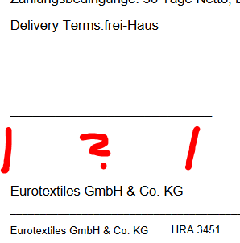

**------------------------------------------------------------------------------------------------------------------------**

**STORE PURCHASE ORDER**

Printout is not working – ERROR

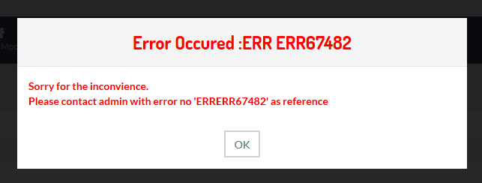

**------------------------------------------------------------------------------------------------------------------------**

**STORE SHIPMENT**

Design is not needed in stores. In other store formats already removed

Articlewise remarks also not needed here

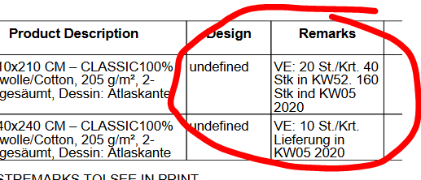

--------------------------------------------------------------------------------------------------------------------------------------

**German & English:** Eurotextiles Name/Adress needs to be shown in header above customer adress (same as in other formats)

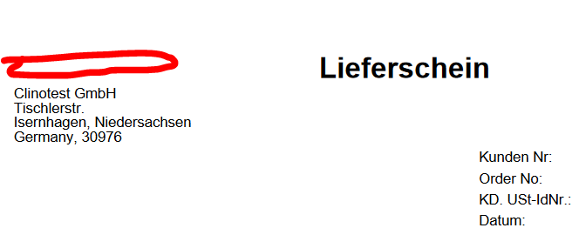

**STORE ONE-MANY INVOICE**

**German & English:** Eurotextiles Name/Adress needs to be shown in header above customer adress (same as in other formats)

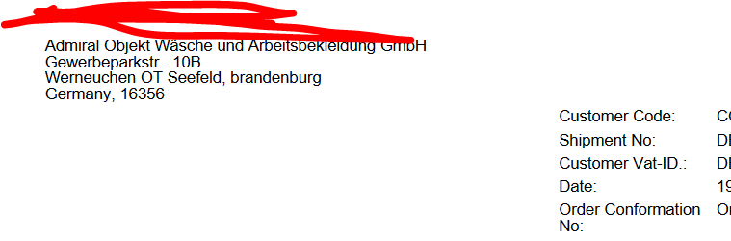

--------------------------------------------------------------------------------------------------------------------------------------

**English:** „Order Confirmation No.“ Is shown several times in wrong places. It only needs to be there in upper right block.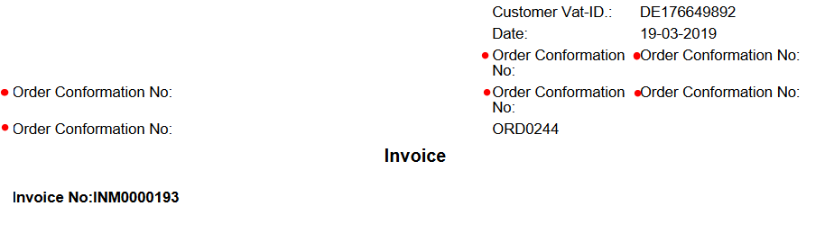

--------------------------------------------------------------------------------------------------------------------------------------

German: Translations missing. Also heading and qty should show in line. I believe this will come automatically if you remove remarks/Design

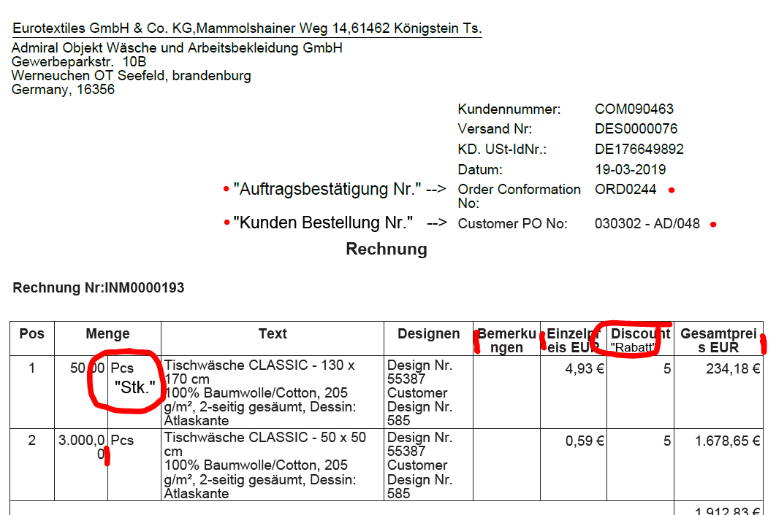

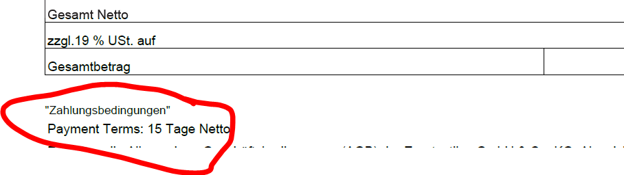

--------------------------------------------------------------------------------------------------------------------------------------

As also in other formats the german terms are not correct (for example in Tradeing: Customer Order is showing „Kundenpono“, „Bestätigung Nein“ is wrong etc.

Given below list of correct german terms for english words.

Wherever those english words appear please make sure to use the right translation in german printouts. If you have a doubt with other words please let me know

|  |  |
| --- | --- |
| **English** | **German** |
| Customer Code | Kunde Nr. |
| Processed By | Bearbeitet von |
| Date | Datum |
| Order Conformation No | Auftragsbestätigung Nr. |
| Customer PO No | Kundenbestellung Nr. |
| Order confirmation | Auftragsbestätigung |
| Quantity | Menge |
| Discount | Rabatt in % |
| Total | Gesamt |
| Payment Terms | Zahlungsbedingungen |
| Remarks | Anmerkungen |
|  |  |
|  |  |
|  |  |
|  |  |